Year 1 Take Home Tasks

Into the Woods

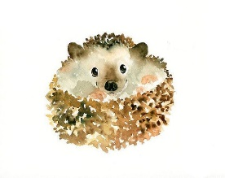

**Our take home tasks this term are focusing on the arts.**

**Please complete at least one of the following take home tasks and bring this into school before 30th November.**

**Remember it’s okay to work with your family members to create your take home task.**

**As Creative Writers**

Write a poem that could be about:

* The 4 seasons or just focus on autumn.
* Woodland animals.
* Trees

Think about how you might present your poem to make it look attractive.

**OR**

Write and decorate a description of what it would be like to walk through an autumn woodland. Think about your senses to help you.

**As Performers**

Create your own autumn dance or perform an autumn poem.

*You could be the leaves swirling as they fall from the trees or the different woodland animals that live in the woods.*

You could record this and email it into school to share with your class, or you could rehearse at home and then perform it to your class.

**As Musicians**

Create a piece of music that shows a change in weather.

Find objects that make sounds to represent, calmness, rain, wind or even stormy weather.

You could record this and email it into school to share with your class, or you could rehearse at home and then perform it to your class.

**As Artists**

Create a mask of a woodland creature so that Isaac has a friend to play with. For example: fox, badger, hedgehog or rabbit. Be as creative as you wish with a range of materials!

**OR**

Take photos of leaves, trees and other woodland objects. Create a photo collage with all of your snaps! Research photography art and see how creative you can be with the photos you

take.

